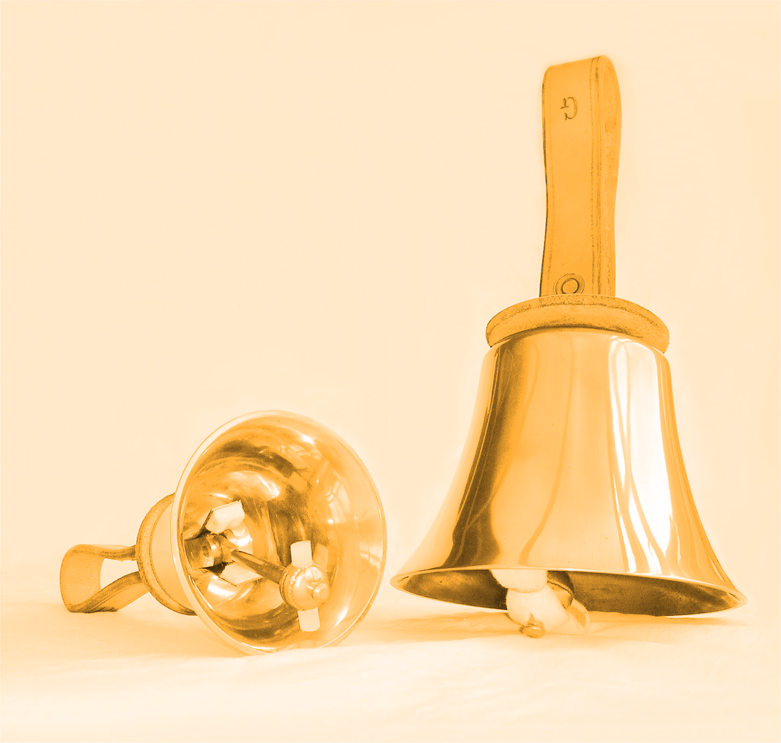
DZWONKI KOŃCZEWICE
- 8.40-9.25
- 9.30-10.15
- 10.25-11.10
- 11.25-12.10
- 12.20-13.05
- 13.15-14.00
- 14.00-14.45
- 14.10-14.55

